Maintenance Plan

ICSI-418 Final Project

Version 1.0 ● May 1, 2019

Maintenance Plan

Luke Prescott, Sean Loucks, Jack Holden, Max Moore, Chin Wa Cheung, Will Dahl, Gary Passarelli

ICSI-418 Final Project

Version: 1.0 Revision Date 5/2/2019

Table of Contents

AExecutive Summary 8

A.1Background 8

A.2Objectives 8

A.3Scope 8

A.4Relationship to Other Plans 9

BSystem Details 10

B.1System Organization 10

B.2Details 10

B.2.1Security 10

B.2.2Points of Contact 10

B.2.3Authorized Usage 10

CSupport Environment 11

C.1Equipment Environment 11

C.1.1Computer Hardware 11

C.1.2Facilities 11

C.2Support Software 11

C.3Storage Requirements 11

DProject Team 12

D.1Roles and Responsibilities 12

D.2Training 12

EManagement Approach 13

E.1Priorities 13

E.2Schedule 13

E.3Tasks 13

E.4Constraints 14

E.5Assumptions 14

E.6Dependencies 14

FTechnical Approach 15

F.1Types of Maintenance Activities 15

F.2Configuration Management 15

F.3Risk Assessment 15

F.4Testing 15

F.5System Protection 15

F.6Special Processes 15

F.7Maintenance Reports 15

F.8Documentation 16

F.9Quality Assurance Activities 16

GMaintenance Procedures 17

G.1Consolidated Unit List 17

G.2Maintenance Procedure for Software Unit [x] 17

G.2.1Description 17

G.2.2Conventions 17

G.2.3Verification Procedures 17

G.2.4Error Conditions 18

G.3Maintenance Procedure for Software Unit [x] 18

G.3.1Description 18

G.3.2Conventions 18

G.3.3Verification Procedures 18

G.3.4Error Conditions 18

G.4Maintenance Procedure for Software Unit [x] 18

G.4.1Description 18

G.4.2Conventions 18

G.4.3Verification Procedures 18

G.4.4Error Conditions 18

HDatabase Maintenance Procedure 19

H.1Database [x] 19

H.1.1General Characteristics 19

H.1.2Organization and Detailed Description 19

Document History

Paper copies are valid only on the day they are printed. Contact the author if you are in any doubt about the accuracy of this document.

Revision History

|  |  |  |  |
| --- | --- | --- | --- |
| Revision Number | Revision Date | Summary of Changes | Author |
| 1.0 | 5/2/19 | Document created | Dev team |

Reference Documents

Please see the following documents for more information:

|  |  |  |
| --- | --- | --- |
| Document Name | Version | Author |
|  |  |  |

Distribution List

This document has been distributed to:

|  |  |  |  |
| --- | --- | --- | --- |
|  | Position | Company | Action |
| [GitHub](https://github.com/lprescott/ICSI418-Group-Project) |  |  |  |

# Executive Summary

The Maintenance Plan is used to maintain an IT system(s) by describing the system maintenance procedures, operating environment, security, and other control requirements. Maintenance begins when all, or part of the system, has been accepted and all support software and documentation has been delivered. Typically, Maintenance Plans cover the following:

Scope of maintenance/maintenance activities

The identification of the initial status of the system

Structure of the support organization

Corrective action to be taken for each type of defect

Maintenance records and reports

## Background

The final project completed is a web-based application. More specifically, it is a testing tool that’s function is the managing, administration, and taking of multiple-choice and true-false examinations. The goal of the project is to create a testing system, which includes a user component, where one can take any number of assigned tests, receiving said results, as well as viewing results of previously taken tests. The testing system also includes an administrative component where one can create, read, update and delete all types of users, questions (answers), and tests – as well as view user’s results.

## Objectives

More specific requirements include: users are identified by and login through an email and password; users can be marked inactive by an administrator and are therefore not allowed to login; users are emailed their identification information upon account creation by an administrator; questions are to be categorized and can contain images as well as text; upon taking a test, a user’s progress should be saved actively as they answer questions; the header image, header text, and footer text should be customizable by each administrator; a test with questions and answers can be uploaded to the web-app in the form of a csv file, propagating through the database.

## Scope

The scope establishes the boundaries of the document and should describe activities outside of the scope, for example, if certain components are not included in the plan due to budgetary, technical or contractual reasons.

## Relationship to Other Plans

Program description: [README.md](https://github.com/lprescott/ICSI418-Group-Project/blob/master/README.md)

https://github.com/lprescott/ICSI418-Group-Project/blob/master/README.md

[Project Backlog](https://github.com/lprescott/ICSI418-Group-Project/blob/master/project-logistics/Product-Backlog.pdf)

System Organization

In this section, provide a brief description of the system structure, major system components, and the functions of each major system component. Include charts, diagrams, and graphics as necessary.

## https://lh3.googleusercontent.com/_0BUNm1xsRvCYf1vYwQ_0Ynw028K_Mf_2-o0m-pokk3Irip4cyLiSGDp2VFboHsn6iJYaWz74pQSnhgAbwySqsWkVgkCNngVvfTnYyXX5PiTgDWDrtPkPMxD4FthfvKM-CeDKvYBeYs

## Details

Provide details of the system(s) to be maintained:

Project Owner: development team

Department responsible: none

System name: AWS

System category: Windows Server

Operational status: end of life 5/2/2019

### Security

All passwords are encrypted

### Points of Contact

NONE

### Authorized Usage

This was a class project anyone wants to continue development is welcome to.

Support Environment

This Project was deployed to AWS running Windows Server.

## Equipment Environment

AWS Cloud server

### Computer Hardware

This Project was deployed to AWS running Windows Server

### Facilities

None

## Software Dependencies

* javax.servlet-api 4.0.1
* javax.servlet.jsp-api 2.3.3
* jstl 1.2
* mysql-connector-java 8.0.15
* javax.mail 1.6.2
* commons-io 1.3.2
* commons-fileupload 1.4
* opencsv 4.5

## Storage Requirements

All storage is on AWS cloud server.

# Project Team

Identify the team members by functional job description. State the approximate percentage of each team member's time that will be required to be devoted to the project(s).

## Roles and Responsibilities

Describe each person(s) responsibility for ensuring the maintenance activities are performed.

Describe each person(s) role and responsibility during the test plan. Identify the user groups responsible for all aspects of test plan(s) activities, such as developers, testers, technical writers, and end-users.

|  |  |  |
| --- | --- | --- |
| Name | Role | Responsibility |
| Luke Prescott | Scrum master | Development, tester, tech writer |
| Sean Loucks | Developer | Development, tester, tech writer |
| Jack Holden | Developer | Development, tester, tech writer |
| Max Moore | Developer | Development, tester, tech writer |
| Chin Wa Cheung | Developer | Development, tester, tech writer |
| Will Dahl | Developer | Development, tester, tech writer |
| Gary Passarelli | Developer | Development, tester, tech writer |

Table 1 — Roles and Responsibilities

## Training

None.

# Management Approach

Describe the approach to managing the project; tracking and controlling the project; assumptions, constraints, or dependencies; risk management issues; project estimates (sizing and time); staffing requirements (skills and resource load); and information on schedule and project deliverables.

## Priorities

Describe the approach for determining priorities, for example, if you classify software defects by severity level (e.g. Sev 1, Sev 2, and Sev 3), then describe the procedures for resolving these issues.

## Schedule

See: [product backlog.](https://github.com/lprescott/ICSI418-Group-Project/blob/master/project-logistics/Product-Backlog.pdf)

## Tasks

Time required to complete each task was based on each team members skill level.

## Constraints

Discuss any business or technology constraints that may impact the Maintenance Plan, e.g. resources, schedules, or budgetary issues.

|  |  |  |
| --- | --- | --- |
| Ref. # | Constraint | Impact |
| 1 | End of life | End of life |

Table 3 — Constraints

## Assumptions

None.

## Dependencies

List the main dependencies regarding the Maintenance Plan.

|  |  |  |
| --- | --- | --- |
| Ref. # | Dependency | Action |
| 1 | GitHub | https://github.com/lprescott/ICSI418-Group-Project |

Table 5 — Dependencies

# Technical Approach

## Types of Maintenance Activities

Describe the different type of activities that require maintenance, e.g. resolution, enhancements, and modifications. Review the terms of maintenance (which may be specified in the license or service level agreement).

Typical maintenance activities include:

Problem resolution

Modification and expansion

Performance improvement

Examples of maintenance items include:

Software

Data

Documentation

## Configuration Management

None.

## Risk Assessment

Low risk to system if unit is changed. Higher risk to individual units if database is significantly changed.

## Testing

See: [testing plan](https://github.com/lprescott/ICSI418-Group-Project/blob/master/project-logistics/Testing-Plan-and-Results.pdf)

## System Protection

None.

## Special Processes

None.

## Maintenance Reports

See: [GitHub](https://github.com/lprescott/ICSI418-Group-Project/blob/master/project-logistics/Testing-Plan-and-Results.pdf).

## Documentation

See [GitHub](https://github.com/lprescott/ICSI418-Group-Project/blob/master/project-logistics/Testing-Plan-and-Results.pdf).

## Quality Assurance Activities

See [GitHub](https://github.com/lprescott/ICSI418-Group-Project/blob/master/project-logistics/Testing-Plan-and-Results.pdf).

# Maintenance Procedures

Discuss the procedures necessary for the maintenance team to maintain the software units that make up the system. This section outlines the step-by-step procedures to maintain each software unit.

## Consolidated Unit List

All units created using Eclipse EE in JSP with Java backbone.

|  |  |  |
| --- | --- | --- |
| Unit. # | Name | Purpose |
| 1 | Login Page | Allow access to admin or user page |
| 2 | Admin Page | Allow access to create and edit users and tests |
| 3 | Admin management | Edit admin account information |
| 4 | User Management | Edit user information. |
| 5 | Test Management | Edit and create test |
| 6 | Question Management | Edit and create questions |
| 7 | User Page | Allow access to user |
| 8 | Exam Page | Take test |
| 9 | Result Page | View results |
| 10 | Update Page | Update user information |

Table 6 — Unit List

## Maintenance Procedure for Software Unit [1]

Login Page

### Description

This unit provides login function to admin and user pages.

### Conventions

All standard java naming and programming conventions were used.

### Verification Procedures

Functionality was verified by development team.

### Error Conditions

None

## Maintenance Procedure for Software Unit [2]

Admin Page

### Description

This unit provides access to pages that allow administrators to view and edit user information. The admin page also allows administrators to view and edit test information.

### Conventions

All standard java naming and programming conventions were used

### Verification Procedures

Functionality was verified by development team

### Error Conditions

None

## Maintenance Procedure for Software Unit [3]

Admin management

### Description

This unit allows administrator to edit admin account information.

### Conventions

All standard java naming and programming conventions were used

### Verification Procedures

Functionality was verified by development team.

### Error Conditions

None

## Maintenance Procedure for Software Unit [4]

User management

### Description

This unit allows administrator to edit user account information.

### Conventions

All standard java naming and programming conventions were used.

### Verification Procedures

Functionality was verified by development team.

### Error Conditions

None

## Maintenance Procedure for Software Unit [5]

Test Management

### Description

Gives administrator ability to create and edit tests.

### Conventions

All standard java naming and programming conventions were used.

### Verification Procedures

Functionality was verified by development team.

### Error Conditions

None

### Maintenance Procedure for Software Unit [6]

Question Management

### Description

Gives administrator ability to create and edit test questions.

### Conventions

All standard java naming and programming conventions were used.

### Verification Procedures

Functionality was verified by development team.

### Error Conditions

None.

## Maintenance Procedure for Software Unit 7

User Page

### Description

User page is for the user to take and view tests.

### Conventions

All standard java naming and programming conventions were used.

### Verification Procedures

Functionality was verified by development team.

### Error Conditions

None

## Maintenance Procedure for Software Unit 8

Exam Page

### Description

Gives users ability to take test.

### Conventions

All standard java naming and programming conventions were used.

### Verification Procedures

Functionality was verified by development team.

### Error Conditions

None

## Maintenance Procedure for Software Unit 9

Result Page

### Description

Gives users ability to view test results.

### Conventions

All standard java naming and programming conventions were used.

### Verification Procedures

Functionality was verified by development team.

### Error Conditions

None

## Maintenance Procedure for Software Unit 10

Update Page

### Description

Gives user ability to update their information.

### Conventions

All standard java naming and programming conventions were used.

### Verification Procedures

Functionality was verified by development team.

### Error Conditions

None

# Database Maintenance Procedure

This is a SQL database developed with MySQL and Eclipse EE.

## Database [x]

The database is accessed by all units via java backbone.

### General Characteristics

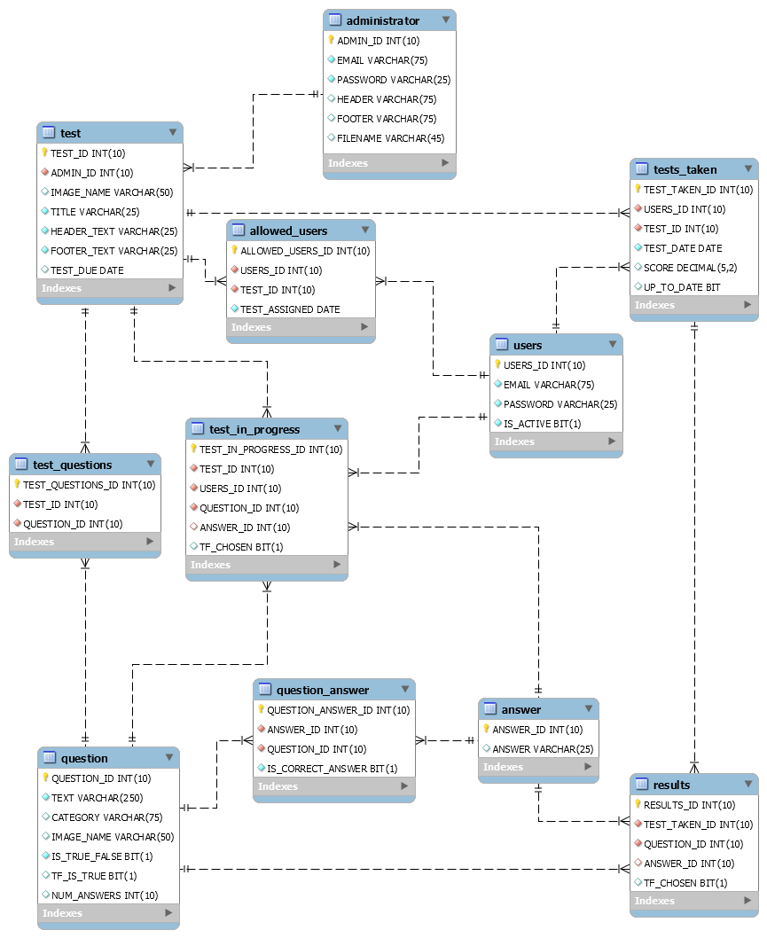

#### Permanency

The database contains dynamic data. Inactive users will need to be removed

#### Storage

1GB recommended.

#### Restrictions

None.

### Organization and Detailed Description

See: [ER-Diagram.](https://github.com/lprescott/ICSI418-Group-Project/blob/master/project-logistics/MySQL-er-diagram.png)

#### Structures

See: [ER-Diagram.](https://github.com/lprescott/ICSI418-Group-Project/blob/master/project-logistics/MySQL-er-diagram.png)

#### Elements

See: [ER-Diagram.](https://github.com/lprescott/ICSI418-Group-Project/blob/master/project-logistics/MySQL-er-diagram.png)

#### Expansion

None.

#### Location

Database is located on AWS server.